CODE SMELL

* SPECULATIVE GENERALITY

**Location in the code:** src/main/java/org/jabref/gui/groups/MoveGroupChange

The class UndoableMoveGroup is never used.

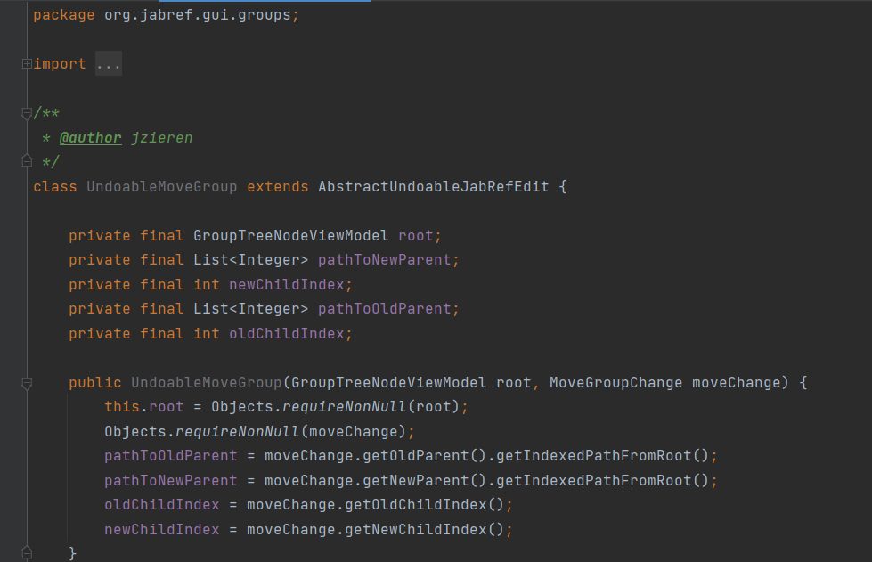

Perhaps if we erase this class, the code smell will disappear.